MongoDB Complete Commands – Student Collection
Beginner-Friendly Practical Manual

1. Database Commands
show dbs
use studentDB
db
db.dropDatabase()
show dbs – Show all databases
use studentDB – Create/select database
db – Show current database
db.dropDatabase() – Delete current database
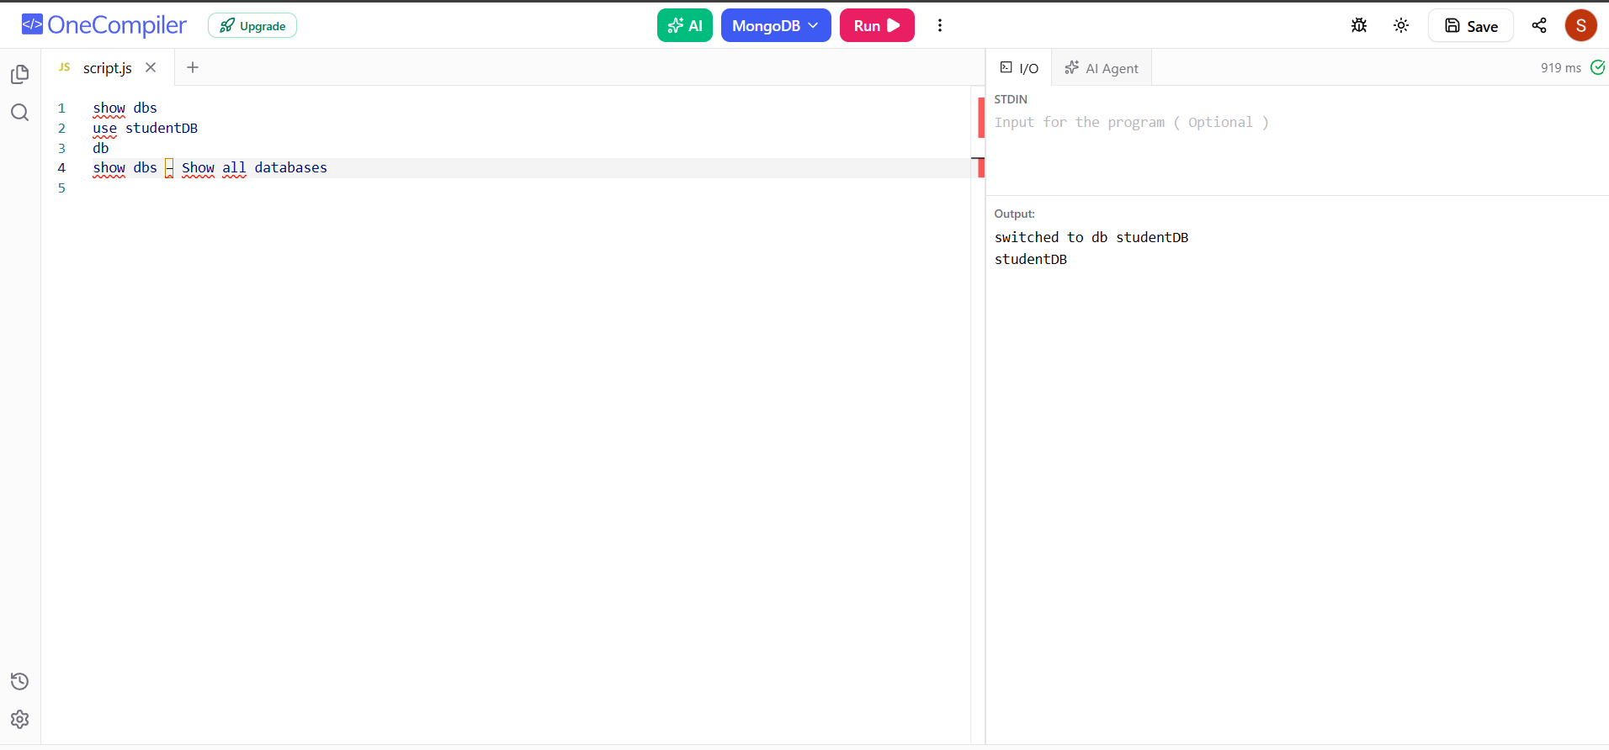

2. Collection Commands
show collections
db.createCollection("students")
db.students.drop()
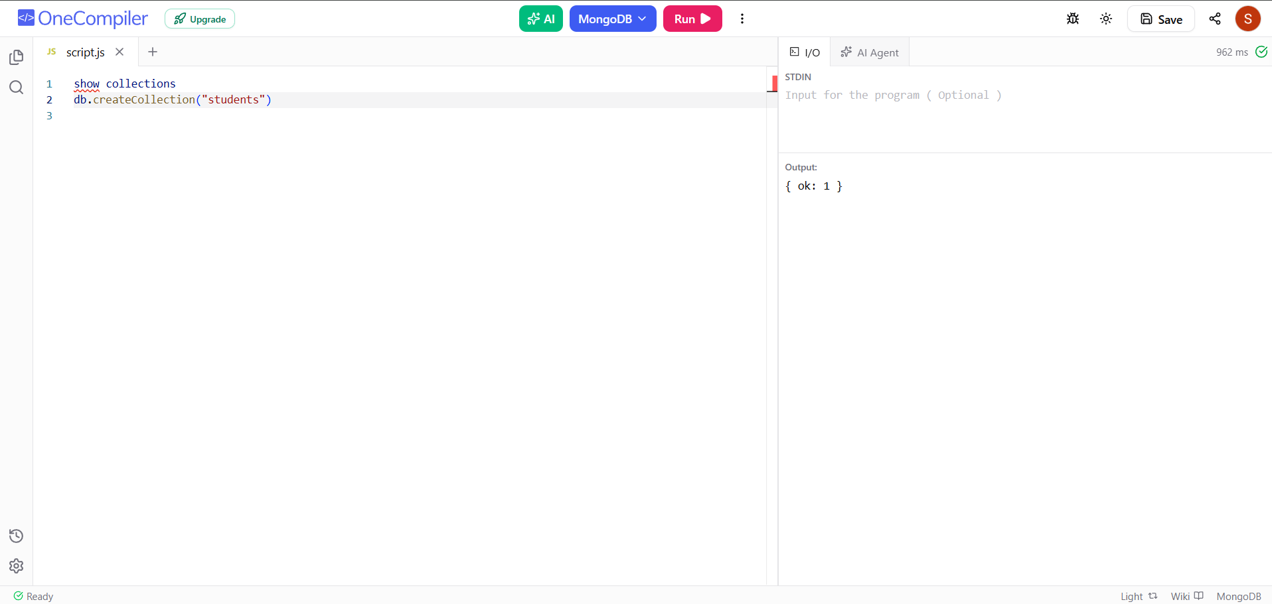

3. Sample Student Data
db.students.insertMany([
{ rollNo: 101, name: "John", age: 20, department: "CSE", marks: 85, city: "Hyderabad" },
{ rollNo: 102, name: "Alice", age: 21, department: "CSE", marks: 90, city: "Vijayawada" },
{ rollNo: 103, name: "Rahul", age: 20, department: "ECE", marks: 75, city: "Hyderabad" },
{ rollNo: 104, name: "Priya", age: 22, department: "IT", marks: 88, city: "Warangal" },
{ rollNo: 105, name: "Kiran", age: 21, department: "CSE", marks: 95, city: "Hyderabad" },
{ rollNo: 106, name: "Anu", age: 20, department: "IT", marks: 82, city: "Guntur" },
{ rollNo: 107, name: "Ravi", age: 23, department: "ECE", marks: 68, city: "Nellore" },
{ rollNo: 108, name: "Sita", age: 21, department: "CSE", marks: 91, city: "Hyderabad" },
{ rollNo: 109, name: "Arun", age: 22, department: "AI&DS", marks: 87, city: "Kurnool" },
{ rollNo: 110, name: "Meena", age: 20, department: "AI&DS", marks: 93, city: "Hyderabad" }
])
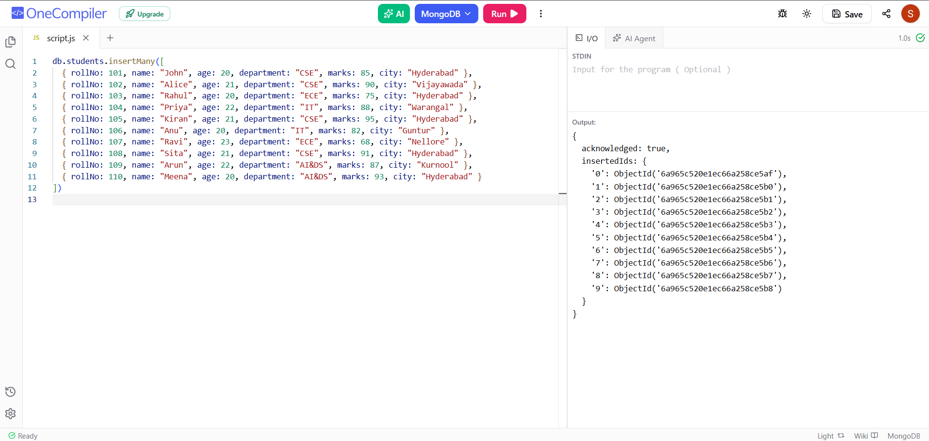

4. CREATE – Insert Commands
db.students.insertOne({
rollNo: 111,
name: "Vijay",
age: 21,
department: "CSE",
marks: 86,
city: "Hyderabad"
})
db.students.insertMany([
{ rollNo: 112, name: "Pooja", age: 20, department: "IT", marks: 84 },
{ rollNo: 113, name: "Ramesh", age: 22, department: "ECE", marks: 79 }
])
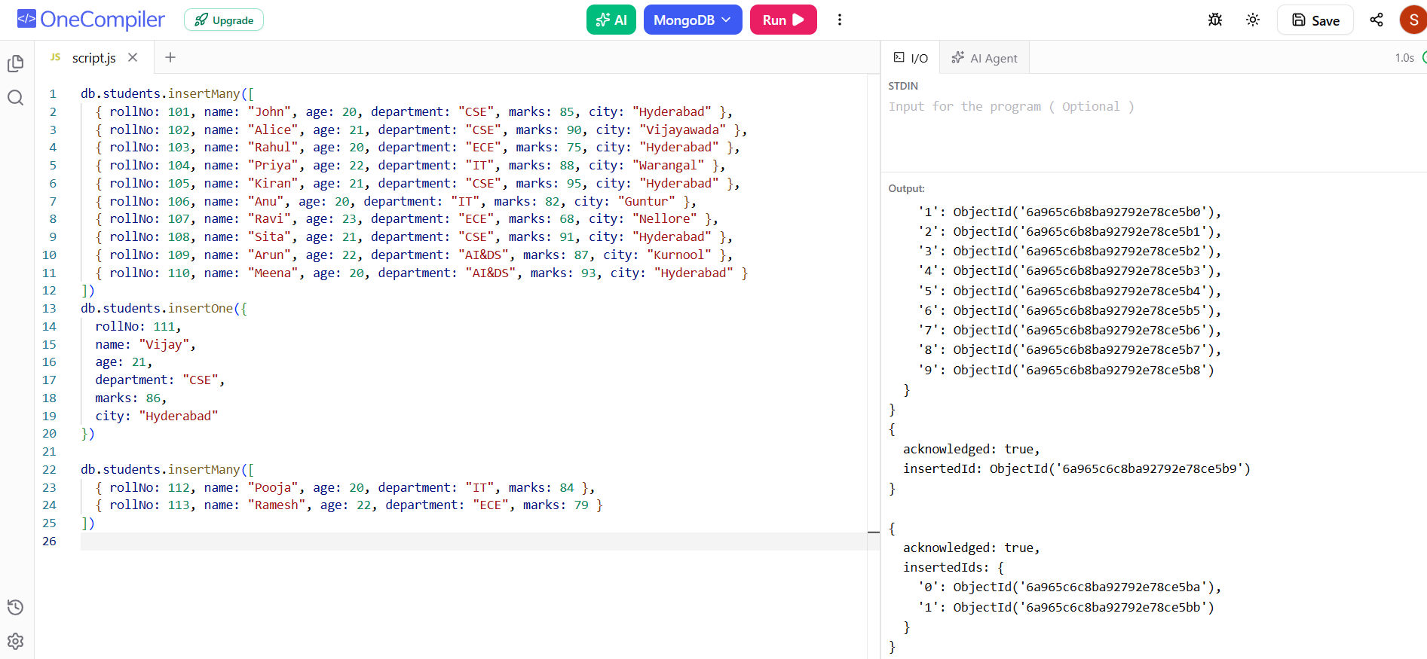

5. READ – Basic Find Commands
db.students.find()
db.students.findOne()
db.students.findOne({ rollNo: 101 })
db.students.find({ department: "CSE" })
db.students.find({ name: "John" })
db.students.countDocuments()
db.students.countDocuments({ department: "CSE" })
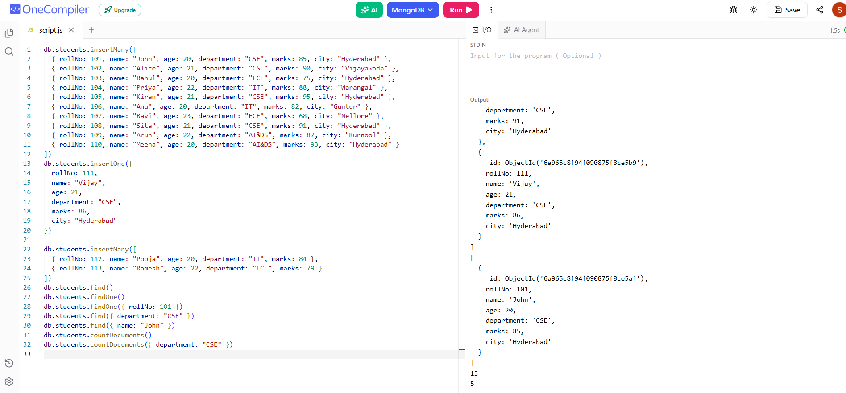

6. Comparison Operators
// Greater than
db.students.find({ marks: { $gt: 80 } })
// Greater than or equal
db.students.find({ marks: { $gte: 80 } })
// Less than
db.students.find({ marks: { $lt: 80 } })
// Less than or equal
db.students.find({ marks: { $lte: 80 } })
// Not equal
db.students.find({ department: { $ne: "CSE" } })
// Equal
db.students.find({ marks: { $eq: 90 } })
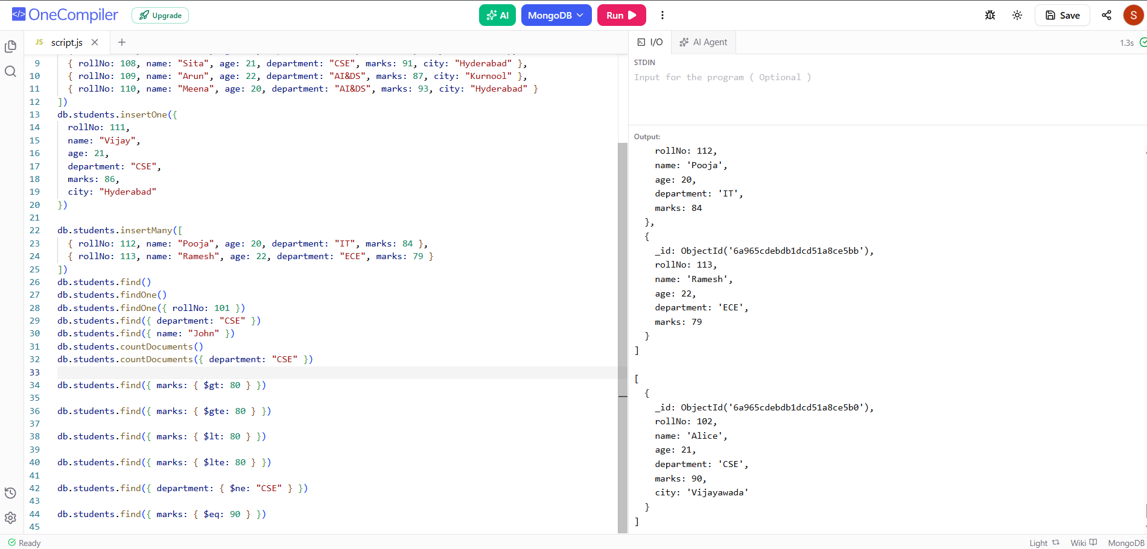

7. Logical Operators
// AND
db.students.find({
$and: [
{ department: "CSE" },
{ marks: { $gt: 85 } }
]
})
// OR
db.students.find({
$or: [
{ department: "CSE" },
{ department: "IT" }
]
})
// NOT
db.students.find({
marks: { $not: { $gt: 80 } }
})
// NOR
db.students.find({
$nor: [
{ department: "CSE" },
{ marks: { $gt: 90 } }
]
})
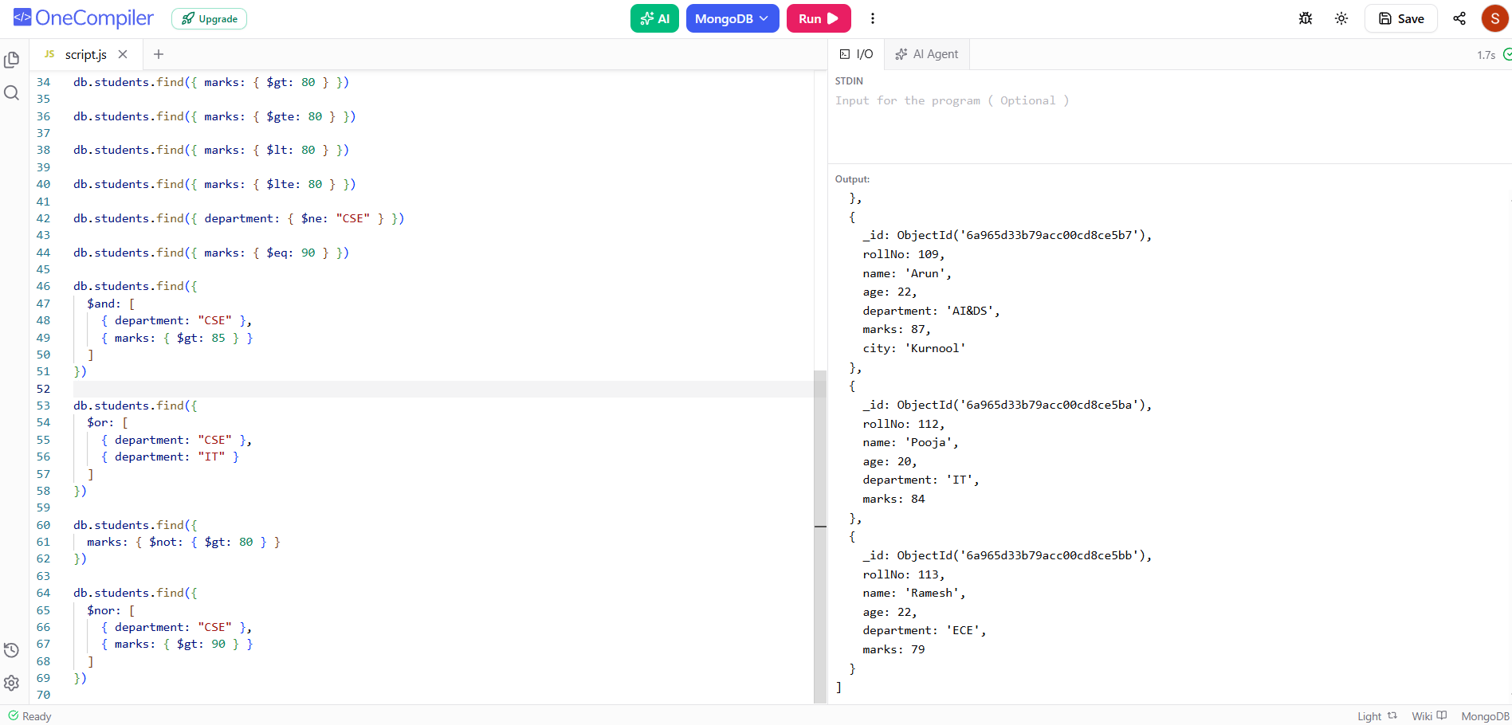

8. IN and NIN Operators
db.students.find({
department: { $in: ["CSE", "IT"] }
})
db.students.find({
department: { $nin: ["CSE", "IT"] }
})
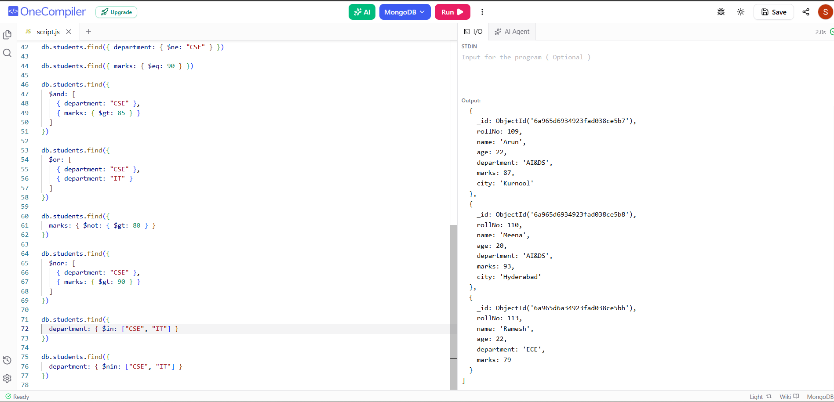

9. UPDATE Commands
// Update one
db.students.updateOne(
{ rollNo: 101 },
{ $set: { marks: 92 } }
)
// Update multiple
db.students.updateMany(
{ department: "CSE" },
{ $set: { status: "Active" } }
)
// Increment
db.students.updateOne(
{ rollNo: 101 },
{ $inc: { marks: 5 } }
)
// Decrement
db.students.updateOne(
{ rollNo: 101 },
{ $inc: { marks: -2 } }
)
// Rename a field
db.students.updateMany(
{},
{ $rename: { "city": "location" } }
)
// Add field
db.students.updateOne(
{ rollNo: 101 },
{ $set: { attendance: 90 } }
)
// Remove a field
db.students.updateOne(
{ rollNo: 101 },
{ $unset: { attendance: "" } }
)
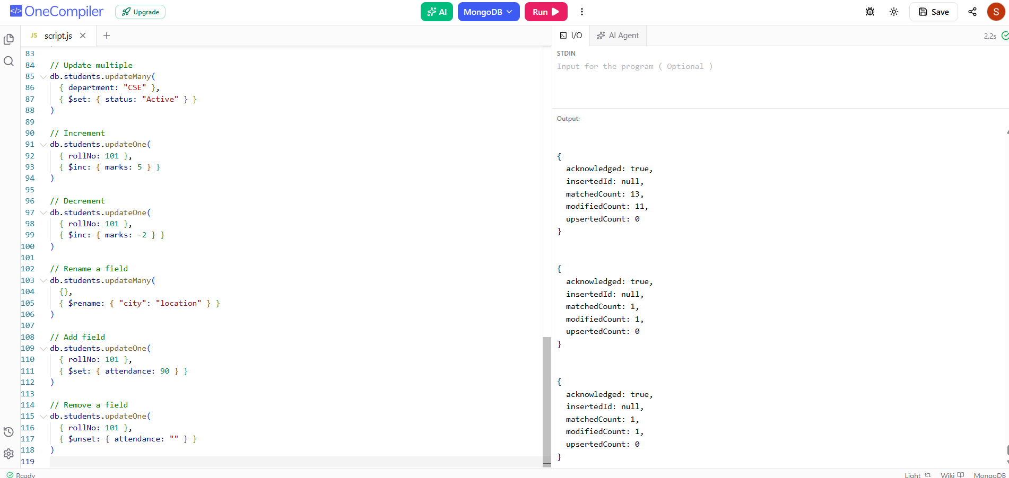

10. DELETE Commands
// Delete one
db.students.deleteOne({ rollNo: 103 })
// Delete multiple
db.students.deleteMany({ marks: { $lt: 40 } })
// Delete all documents
db.students.deleteMany({})
Warning: deleteMany({}) removes every document in the collection.
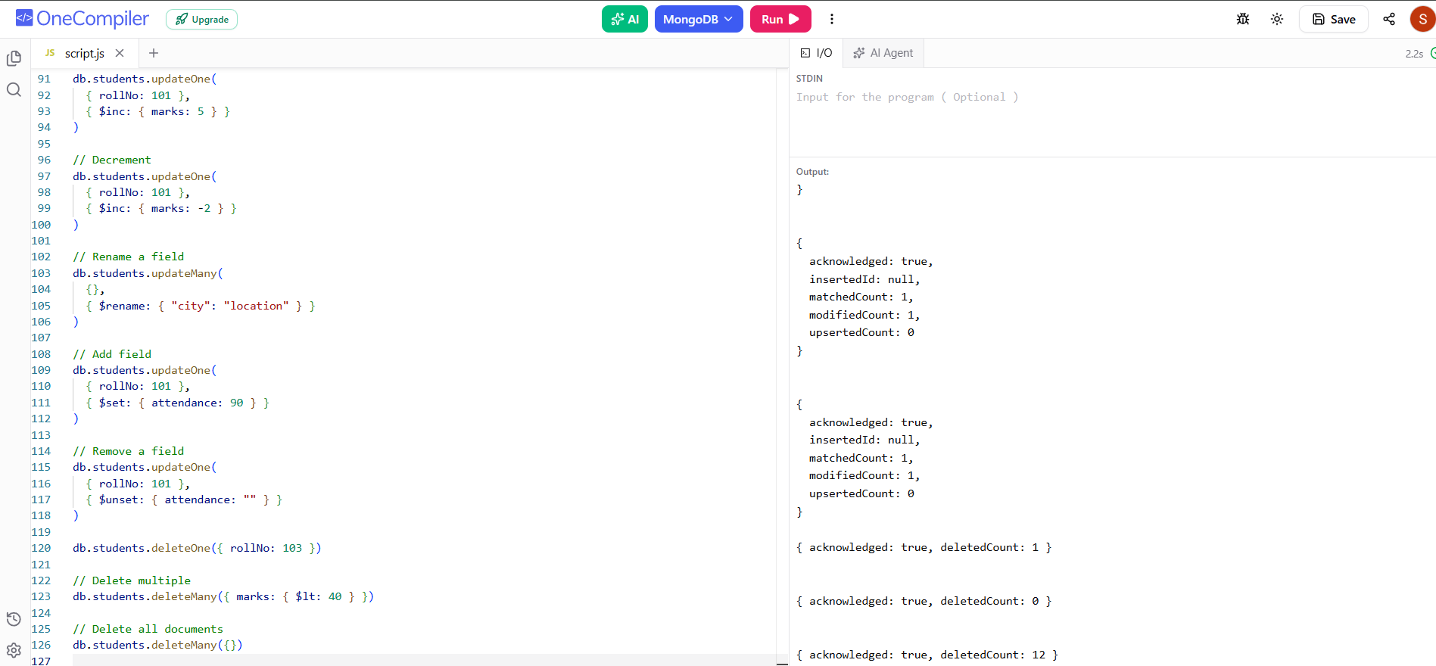

11. Sorting
// Ascending
db.students.find().sort({ marks: 1 })
// Descending
db.students.find().sort({ marks: -1 })
// Sort by department and marks
db.students.find().sort({ department: 1, marks: -1 })
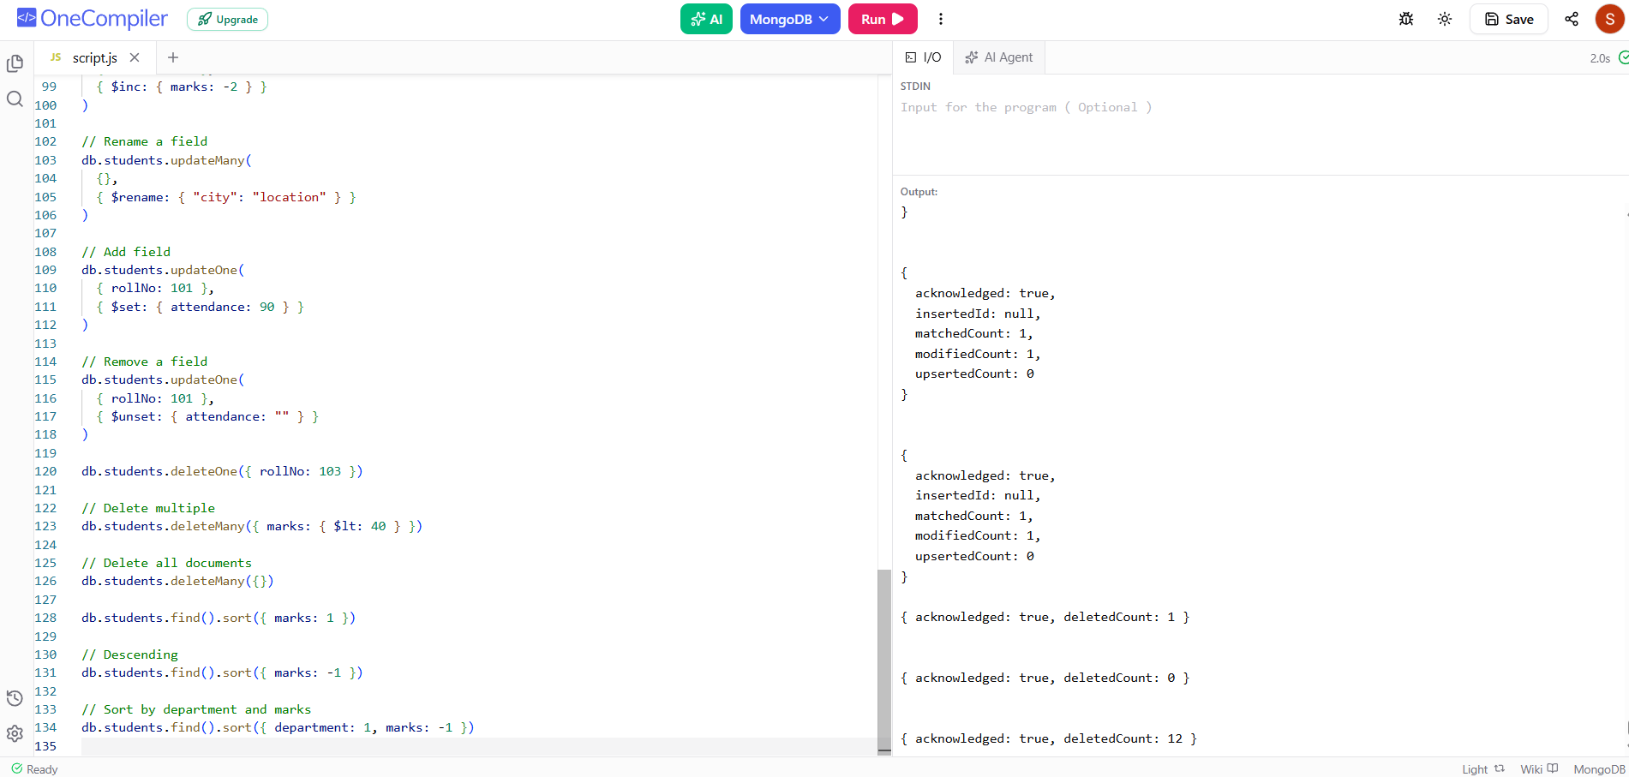

12. Limit and Skip
// First 5 students
db.students.find().limit(5)
// Top 3 students
db.students.find().sort({ marks: -1 }).limit(3)
// Skip first 5
db.students.find().skip(5)
// Skip 2 and show next 3
db.students.find().skip(2).limit(3)
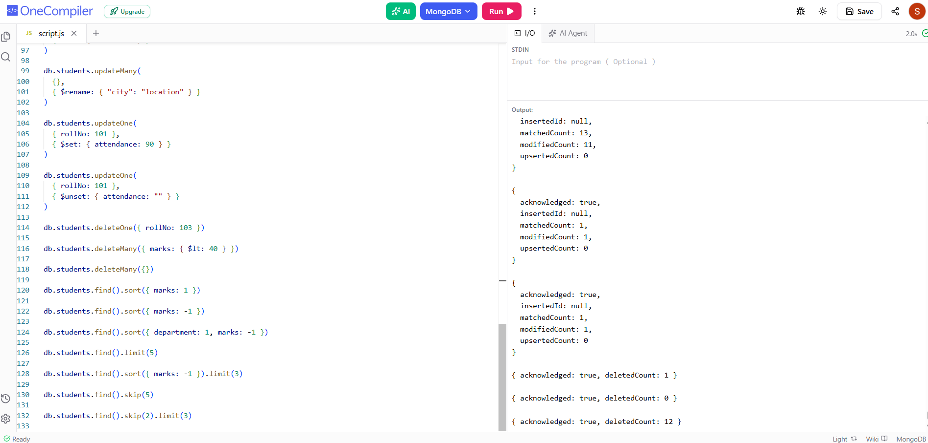

13. Projection
// Only name and marks
db.students.find(
{},
{ _id: 0, name: 1, marks: 1 }
)
// Name, department and marks
db.students.find(
{},
{ _id: 0, name: 1, department: 1, marks: 1 }
)
// Hide age
db.students.find(
{},
{ age: 0 }
)
Note: In a projection, normally use either inclusion (1) or exclusion (0), except _id can be excluded with inclusion.
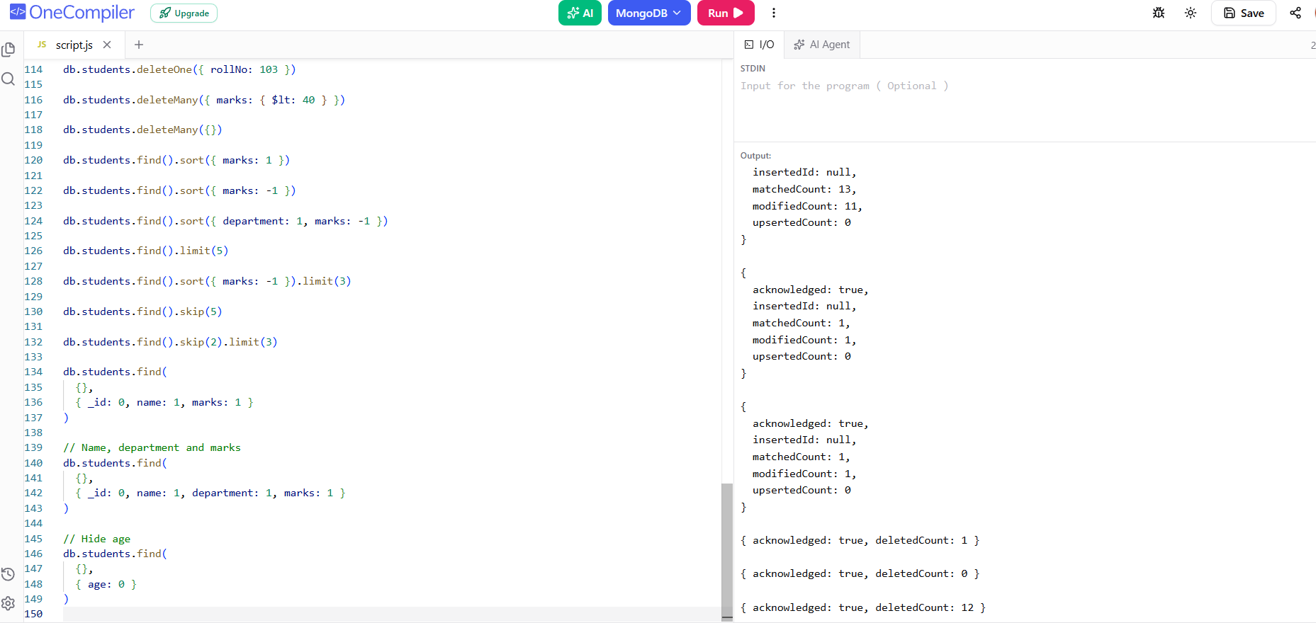

14. Distinct Values
// All departments
db.students.distinct("department")
// All cities
db.students.distinct("city")
// Departments with marks 80 or above
db.students.distinct(
"department",
{ marks: { $gte: 80 } }
)
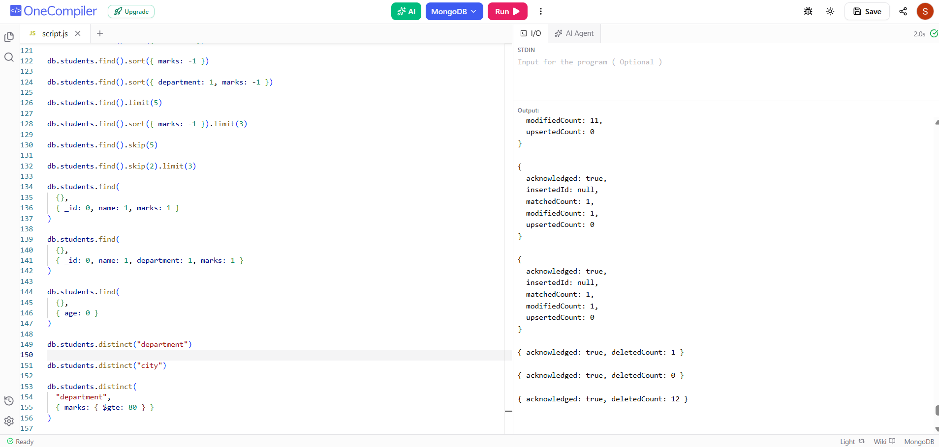

15. Index Commands
// Create index
db.students.createIndex({ rollNo: 1 })
// Create name index
db.students.createIndex({ name: 1 })
// Compound index
db.students.createIndex({ department: 1, marks: -1 })
// Show indexes
db.students.getIndexes()
// Drop name index
db.students.dropIndex("name_1")
// Drop all indexes except _id
db.students.dropIndexes()
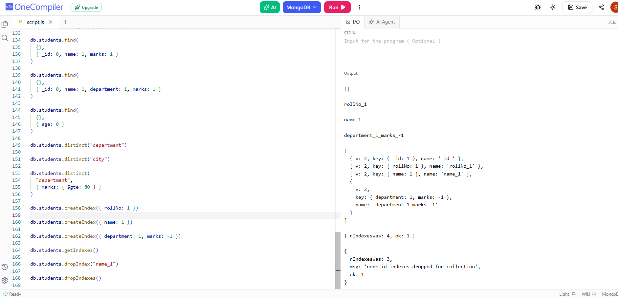

16. Aggregation – Basic Commands
// Display all documents through aggregation
db.students.aggregate([
{ $match: {} }
])
// Students with marks > 80
db.students.aggregate([
{ $match: { marks: { $gt: 80 } } }
])
// Department-wise student count
db.students.aggregate([
{
$group: {
_id: "$department",
totalStudents: { $sum: 1 }
}
}
])
// Department-wise average marks
db.students.aggregate([
{
$group: {
_id: "$department",
averageMarks: { $avg: "$marks" }
}
}
])
// Highest marks
db.students.aggregate([
{
$group: {
_id: null,
highestMarks: { $max: "$marks" }
}
}
])
// Lowest marks
db.students.aggregate([
{
$group: {
_id: null,
lowestMarks: { $min: "$marks" }
}
}
])
// Total marks
db.students.aggregate([
{
$group: {
_id: null,
totalMarks: { $sum: "$marks" }
}
}
])
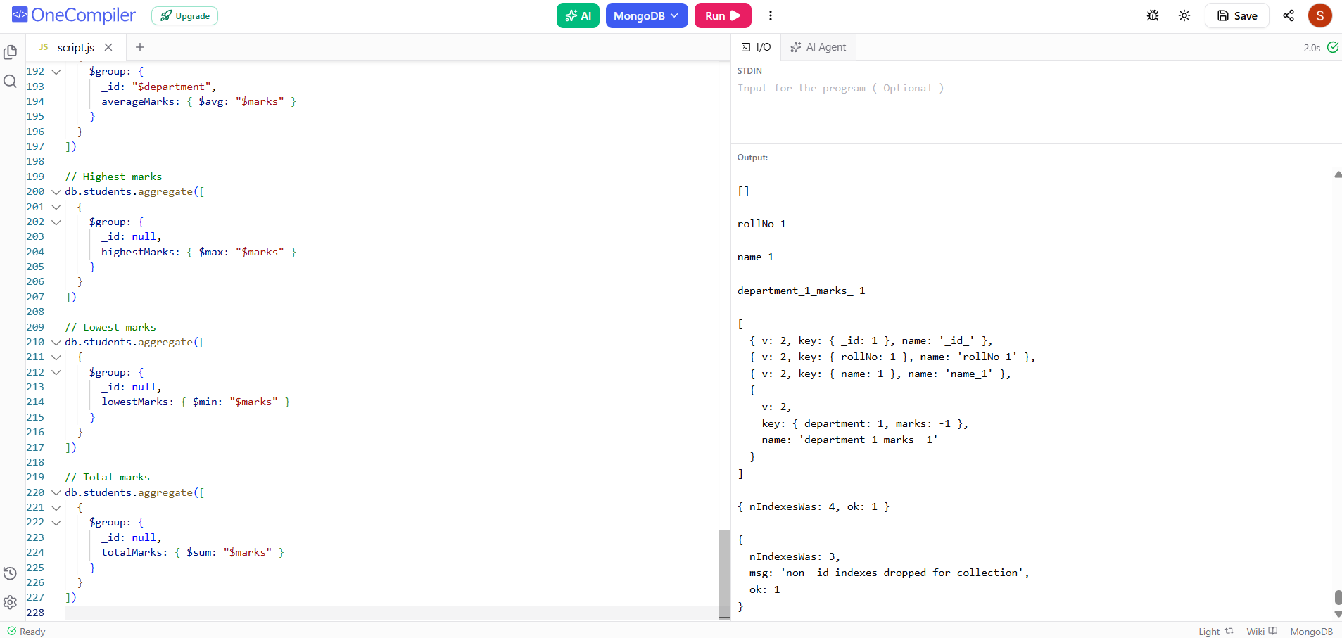

17. Aggregation with Multiple Stages
// CSE students, grouped and sorted by average marks
db.students.aggregate([
{ $match: { department: "CSE" } },
{
$group: {
_id: "$department",
averageMarks: { $avg: "$marks" },
totalStudents: { $sum: 1 }
}
},
{ $sort: { averageMarks: -1 } }
])
// Top 3 students using aggregation
db.students.aggregate([
{ $sort: { marks: -1 } },
{ $limit: 3 },
{
$project: {
_id: 0,
rollNo: 1,
name: 1,
marks: 1
}
}
])
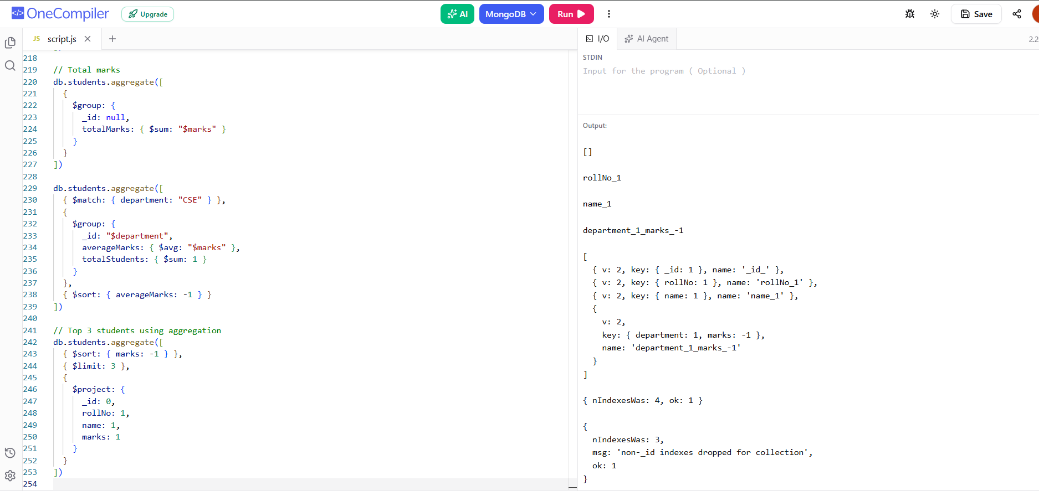

18. Useful MongoDB Commands
show dbs
show collections
db
db.students.find().pretty()
db.students.countDocuments()
db.students.distinct("department")
db.students.getIndexes()
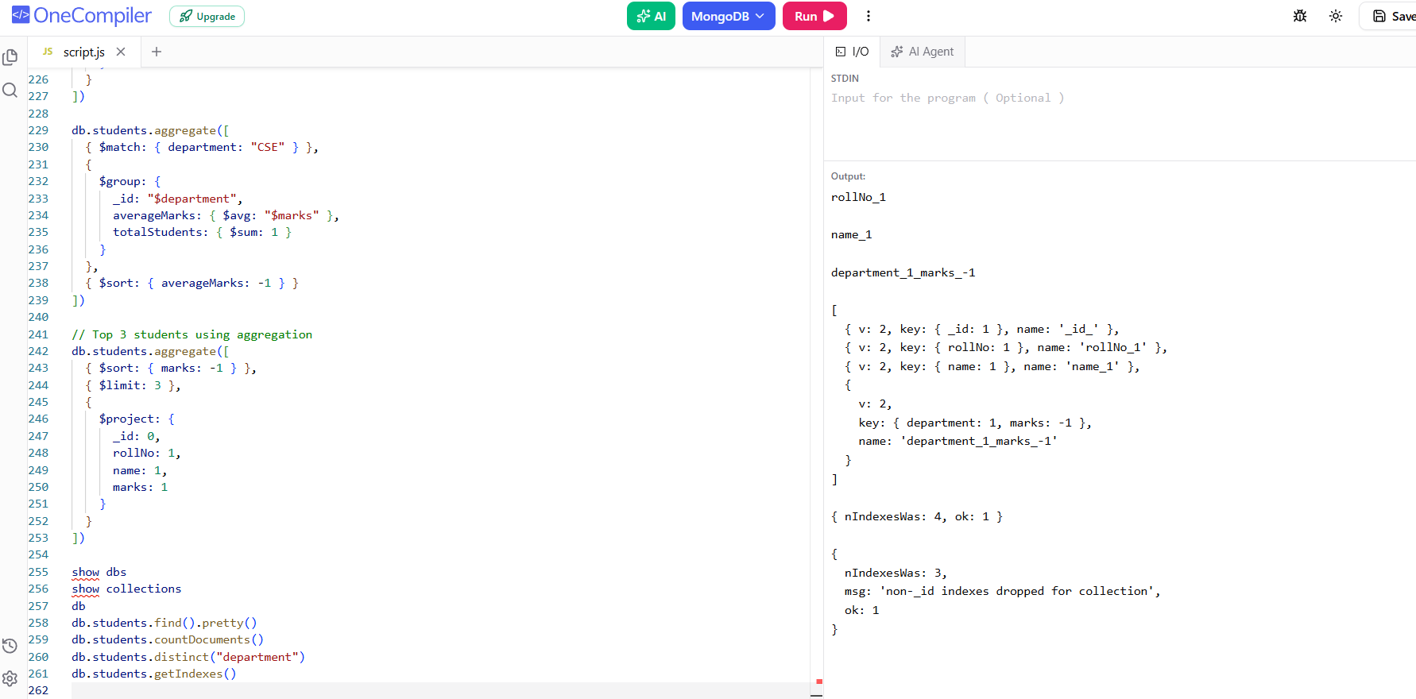

19. Complete CRUD Practical
use studentDB
// CREATE
db.students.insertOne({
rollNo: 201,
name: "Test Student",
age: 20,
department: "CSE",
marks: 85
})
// READ
db.students.find({ rollNo: 201 })
// UPDATE
db.students.updateOne(
{ rollNo: 201 },
{ $set: { marks: 95 } }
)
// DELETE
db.students.deleteOne({ rollNo: 201 })
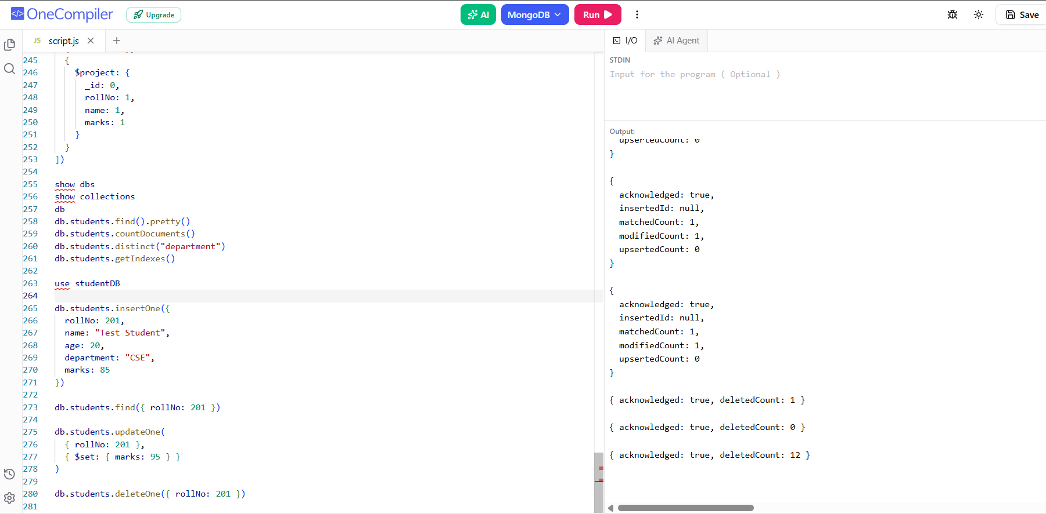

20. Quick Reference Table
Category | Command | Purpose
Database | use studentDB | Select/create database
Collection | db.createCollection() | Create collection
Create | insertOne() | Insert one document
Create | insertMany() | Insert multiple documents
Read | find() | Retrieve documents
Read | findOne() | Retrieve one document
Update | updateOne() | Update one document
Update | updateMany() | Update multiple documents
Delete | deleteOne() | Delete one document
Delete | deleteMany() | Delete multiple/all documents
Sort | sort() | Sort results
Limit | limit() | Limit results
Skip | skip() | Skip results
Projection | find({}, {...}) | Select/hide fields
Index | createIndex() | Create index
Aggregation | aggregate() | Process/group documents

21. Student Practice Exercises
1. Create a studentDB database and students collection.
2. Insert at least 10 student documents.
3. Display all students.
4. Find students from the CSE department.
5. Find students with marks greater than 85.
6. Find students between 70 and 90 marks.
7. Find students from CSE or IT using $or.
8. Update one student's marks.
9. Update all CSE students with a status field.
10. Increase a student's marks using $inc.
11. Delete one student.
12. Delete students whose marks are below 40.
13. Sort students by marks in descending order.
14. Display the top 3 students.
15. Use skip and limit.
16. Display only name, department and marks.
17. Create an index on rollNo.
18. Display all indexes.
19. Find department-wise student count using aggregation.
20. Find department-wise average marks using aggregation.

22. Important Notes
1. MongoDB stores data as BSON documents.
2. A collection is similar to a table in a relational database.
3. A document is similar to a row, but it can have a flexible structure.
4. MongoDB automatically generates an _id field if it is not supplied.
5. Use deleteMany({}) carefully because it deletes all documents.
6. Aggregation uses a pipeline of stages such as $match, $group, $project and $sort.
7. Indexes can improve query performance, but unnecessary indexes consume storage and can affect write performance.

23. CRUD Summary
CREATE → insertOne(), insertMany()
READ → find(), findOne(), countDocuments(), distinct()
UPDATE → updateOne(), updateMany(), $set, $inc, $unset, $rename
DELETE → deleteOne(), deleteMany()
ADVANCED → sort(), limit(), skip(), projection, indexes, aggregate()

